ECOBUY AUTO-SCALING COMPUTE
Modular Assignment 2 | Compute Solution
Md Habib Ahmed | IHC – Cloud Development | October 2026

1. Objective and scope
EcoBuy needed an elastic web application that could withstand sudden traffic spikes without continuously running peak compute capacity. I deployed a Flask-based demonstration on AWS in Stockholm (eu-north-1), using an Application Load Balancer (ALB), Amazon EC2, an Auto Scaling Group (ASG), and Amazon CloudWatch. The goal was to demonstrate load distribution, CPU-driven scaling, service health monitoring, and cost awareness through repeatable tests.

2. Architecture and deployment
The internet-facing ALB forwards HTTP requests to healthy EC2 instances in two Availability Zones. An ASG maintains at least two instances and can increase to five. The target group uses /health to assess availability, while CloudWatch CPU utilisation informs target-tracking scaling. A launch template and EC2 user-data script install Python, Flask and Gunicorn, configure a systemd service, and launch the same application on each new instance.
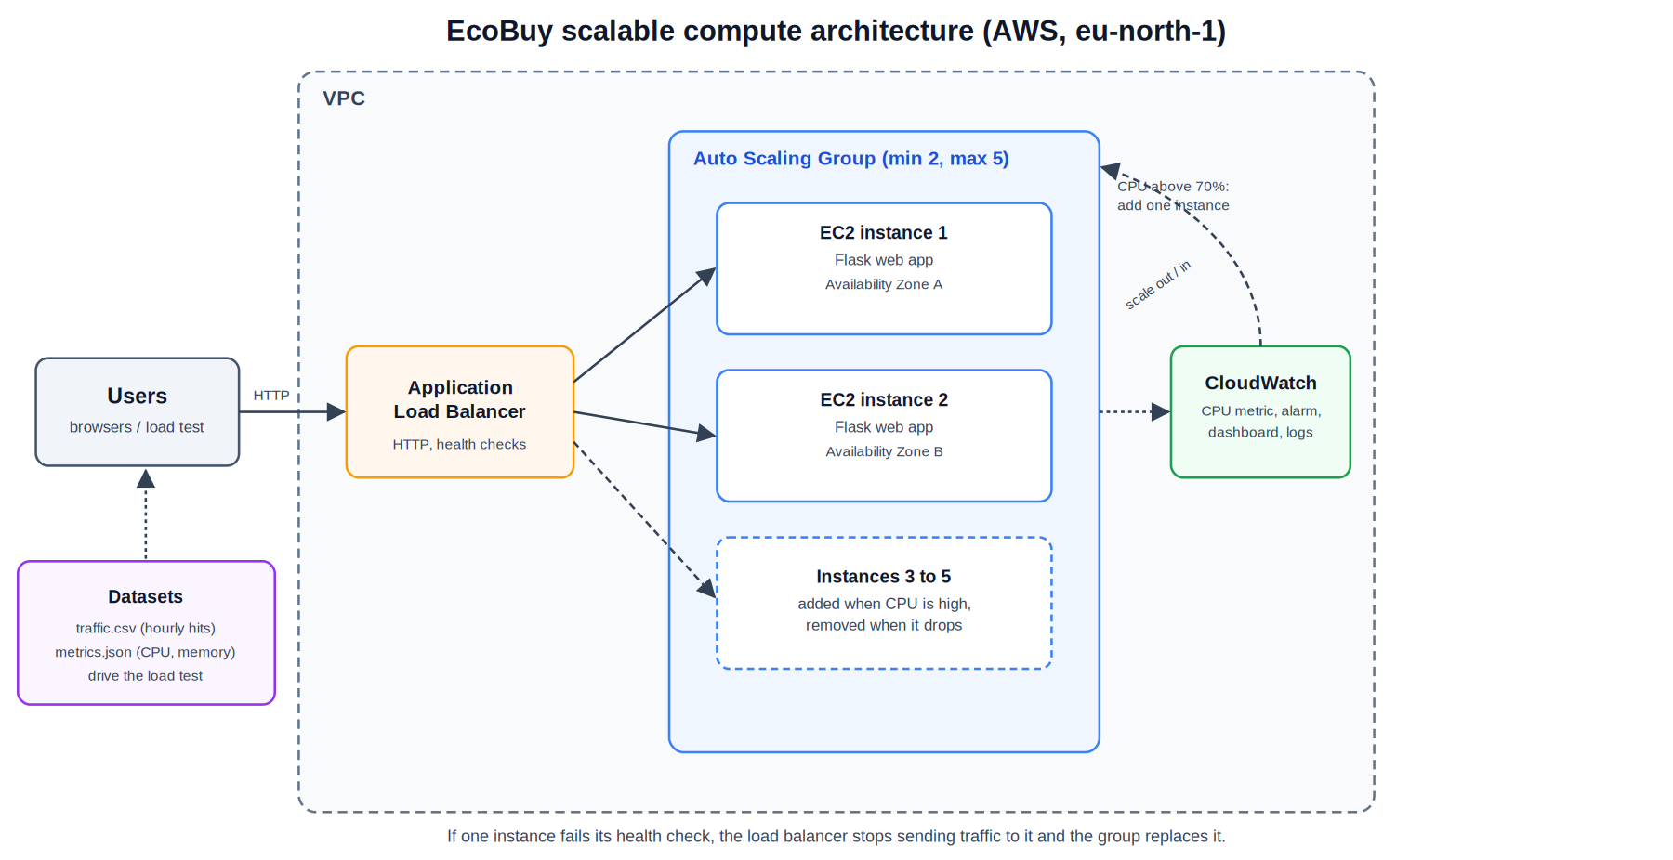
Figure 1. EcoBuy architecture with ALB, multi-zone EC2, ASG and CloudWatch.

3. Application and synthetic datasets
The application exposes / for a sample product catalogue, /api/products for JSON product data, /health for the ALB, and /work for a CPU-intensive test operation. Responses identify the serving instance, making distribution across servers observable. The traffic.csv and metrics.json files contain 168 hourly synthetic observations over seven days, generated reproducibly with a fixed seed. A sale event produces 4,867 simulated peak hits and 97% simulated CPU. These datasets illustrate the scenario; they are not measurements of the deployed EC2 instances.

4. Scaling policy and monitoring
The ASG was configured with minimum 2, desired 2 and maximum 5 instances across eu-north-1a and eu-north-1b. The target-tracking policy aimed for 70% average CPU utilisation with a 300-second instance warm-up. CloudWatch created high- and low-utilisation alarms. During the initial load test the group stayed at two instances; inspection then revealed that the scaling policy had not been created. After configuring the policy, a second test triggered scale-out to three and subsequently five instances. Screenshots also show capacity reducing after demand subsided, although complete scale-in activity logs were not retained.
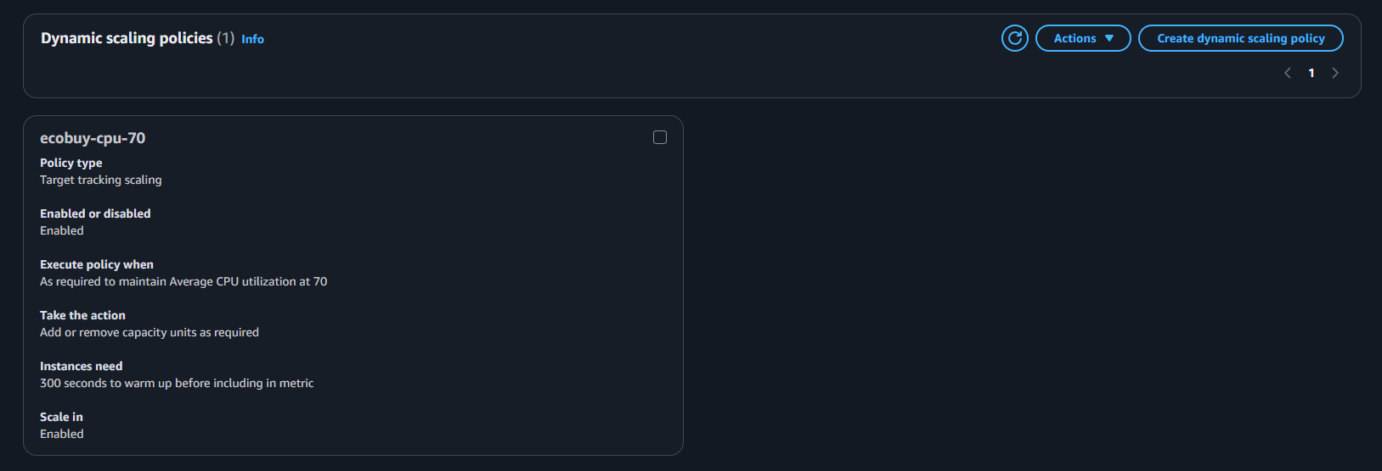
Figure 2. Target-tracking policy configured for 70% average CPU.

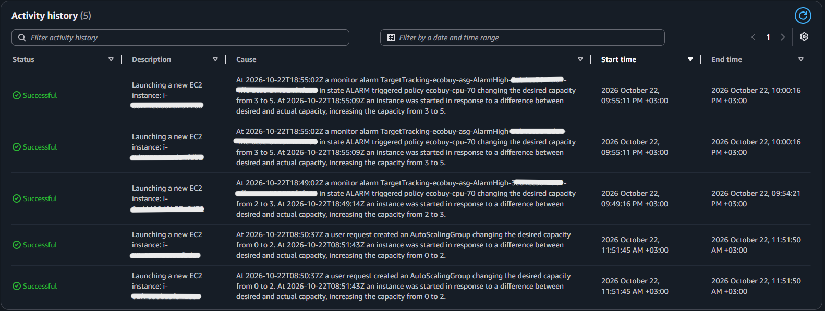
Figure 3. Evidence of the Auto Scaling Group reaching five instances.

5. Load-testing method
A Node.js script sent requests to /work in three stages: a quiet period of 60 seconds at concurrency 2, a 1,200-second spike at concurrency 40, and a 120-second recovery period at concurrency 2. It reported requests, average response time, errors, and distinct responding instance IDs every ten seconds. The spike was designed to increase CPU demand and exercise the ASG policy.

6. Performance evaluation
Observed metric | Run 1: two instances | Run 2: five instances
Spike response time | ~2,010 ms | ~805 ms
Spike throughput | ~200 requests / 10 s | ~497 requests / 10 s
Observed request errors | 0 | 0
Quiet-period latency | ~370–430 ms | ~335 ms
The five-instance measurements were observed toward the end of the second spike, after scaling had occurred. The runs were sequential rather than a controlled simultaneous comparison, but the results are consistent with improved responsiveness and throughput after additional capacity became available. CloudWatch CPU graphs, alarm states and EC2 instance screenshots provide supporting evidence.
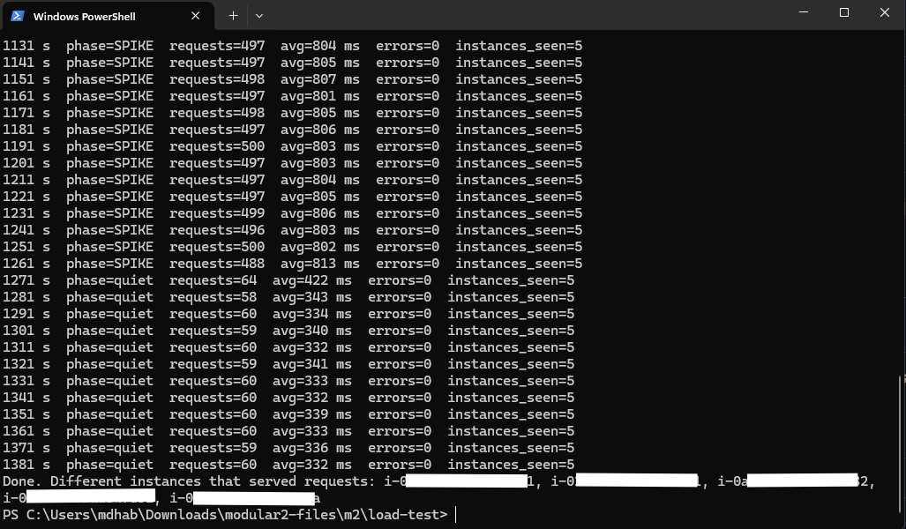
Figure 4. Load-test console output documenting request rates and latency.

7. Availability and operational limitations
The ALB health checks and ASG replacement settings support fault-tolerant operation across two Availability Zones. However, no deliberate instance-termination test was performed, so failover time was not measured. The prototype did not install a centralised application-log agent or custom CloudWatch dashboard. These are documented limitations rather than completed features.

8. Cost and resource efficiency
A pricing estimate placed two continuously running t3.micro instances and an ALB at approximately $38.80 per month in Stockholm, including about $15.77 for compute and $23.03 for the ALB. Five continuously running instances would cost roughly $62 monthly by extrapolation, not by a separate calculator quote. Auto-scaling helps avoid keeping five instances active at all times. Cost Explorer displayed approximately $0.34 in account-level charges at capture; this is not an isolated project invoice. The AWS resources were deleted after testing to avoid ongoing costs.

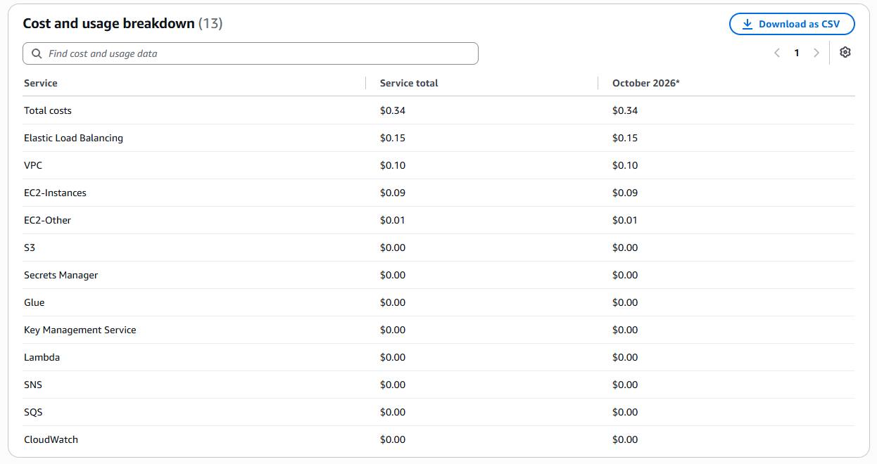
Figure 5. AWS Cost Explorer snapshot captured during the experiment.

9. Security, conclusions and reproducibility
The prototype accepted public HTTP traffic on port 80, and the EC2 security group allowed inbound HTTP from anywhere. For production use, the ALB should terminate HTTPS with a managed certificate, instance ingress should be restricted to the ALB security group, and logging and IAM permissions should be hardened. The experiment demonstrated CPU-triggered scale-out from two to five EC2 instances, load distribution, and observed recovery toward baseline capacity. It also showed lower latency and higher throughput after scale-out. The repository includes the application, bootstrap script, AWS console settings, synthetic datasets, load-test script, architecture diagram and deployment screenshots. The former endpoint is offline because the infrastructure was removed.
Evidence and setup: README.md, config/aws-console-settings.md and screenshots/ in the accompanying GitHub repository.

